In his name

Abu-Dhabi Hoteling Automation System

(ADHAS)

# Overview

You have to develop a software solution in multiple platforms (desktop, mobile and web applications) to cover all needs in an integrated and comprehensive way.

You have been asked to analyze and develop the solution based on following scenario.

# Hotel Rules

This hotel has individual levels for different servicing methods.

* Welcome level (3)
* Member level (2)
* VIP level (1)
* Employees level (E)
* President level: Top rated employee (P)

People in level 1 and 2 must be registered in system and they have a magnetic card which has their info and image printed on. This magnetic cards will be used also as a key to different units such as rooms, parking, saloons, halls, and … in hotel.

Employee level are infrastructure units of hotel such as the kitchen and warehouse. Presidents are like employees who are top rated and can access any place any time. Such as IT System Administrator, CEO, Electrical Emergency Chief and Medical Chief.

The customer who has a room in service, necessarily must gather a valid national document such as national identity card or passport.

Customer ID card is the key to almost everything.

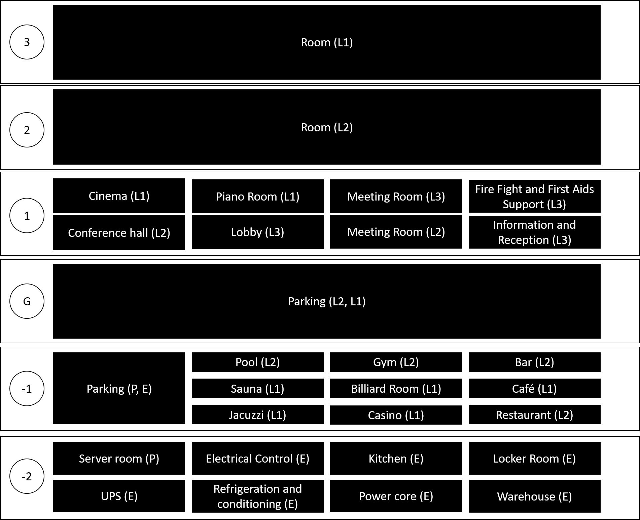

# Guest Registration

There is a web based application that allows users to register to system and submit their info and upload national documents scans with an image.

# Employees

Every employee can be active in multiple positions in same time. It means that you must develop a main screen which will be dynamically customized for each employee who Is logged in to system.

# Guest Reception (Attendance in person)

Receptionist can deny a customer from a unit; for example, youth adults are denied from attending bars. Receptionist will print out the magnetic card for whole family that they will have their own profile and registration; but the reservation will be named for just one.

Customers can reserve a room for a while and they can extend it only if there isn’t any reservation after or the conflicting registration is canceled.

Scheduled time for each unit must be visualized on a Gantt chart available to employees and presidents.

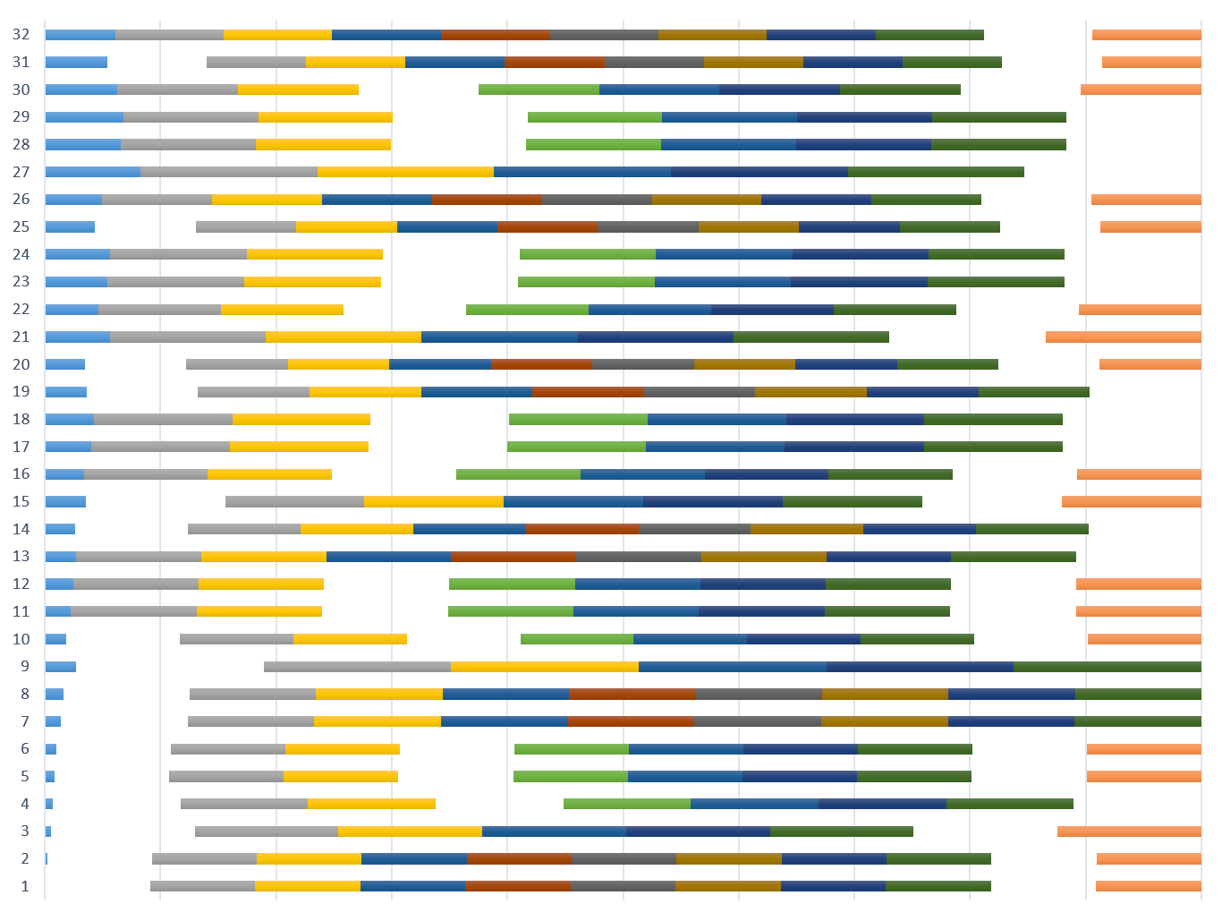

# Units

There are three types of units; PRIVATE, ALWAYS ON and SHOWTIME.

* Private Units such as Rooms, Parking, Safe box.
* Always On Units such as Gym, Bar, Café, Casino, Lobby.
* Showtime units such as Cinema, Conference hall.

# Service Times

There must be no conflict between service time and customer rest time. Private unit services are scheduled and requested by the customer. Showtime units will have auto scheduled service after each program. And Always on units will have services customized periodically (e.g.: each hour, each four hours, each day, two times a week)

Service employees have the right to access to requested room in allowed times. Presidents have the right to access any unit any time.

# Magnetic Card Concept (Mobile)

You have been asked to develop a mobile application that will check the access permission to unit based on identity card serial.



# User Monitor (Mobile)

This form allows employees to check people identities and download info.



# User Registration (Web)

Note: Receptionist will gather the physical document for each reservation.



# Login (Desktop)

There is a single desktop application that handles operations for almost all users in system.

There will be a login form as welcome screen and users will be authorized and redirected to their own menus after authentication.



# Employees main menu

Main menu is outline as below.



As you know, tabs will visible to employee if he/she has position in that unit.

# Customer main menu

Customer doesn’t need password to access the application. The app is available on a tablet inside their room. So the room has an identifier that program will handle all requests through.



# Request Service Schedule and Messaging



# About Abu-Dhabi

This form is just presenting some information about Abu-Dhabi in a slider using images including captions.



# This room



This form allows user to know his roommates better.

# Profile



# Parking

When operator clicks on each parking, “Parking reservation” form will be displayed. In use places must have a graphical difference.



# Parking reservation





# Kitchen and Restaurant, Café and Bar, Meeting Room



Guests will enter the restaurant and they will choose their preferred menu after taking a seat.

# Seat Reservation

Allows garcon to type the food name and it will be auto offer for next use.



# Cinema, Conference Hall, …

This window allows employee manage movies and presentations with times and seat reservation.



And tickets management shown as below:



# Receptionist

The receptionist has same form as `User registration` on his/her desktop which was developed on web interface. Also he/she can manage safe-boxes. Each safe-box will gather to someone and they can access their expensive tools which are hidden in those boxes, only with their magnetic card Id.

Each person has a safe-box reserved by default for each period of their presentation in hotel. Each time any safe-box opens, should be submitted in the system as a log containing the name of employee who was the receptionist stamped with date and time.

No body except the safe-box owner and an employee can open the box. This is a double key lock which will be only open when two magnetic cards are present. If customer reservation date is passed, any of employees has permission to open the safe-box.

Boxes have serial with English alphabet. Logically there are base 25 numbers which are generated automatically in application. There are totally 301 chairs named same as following pattern: **A, B, C, D, E, F, …, AA, AB, …, BA, …**



# Magnetic Card Print Dialog

This will allow the receptionist to print the magnetic card for each customer based on his/her national code and automatically based on their reservation.



# People

This form allows employees to manage people registered to system.



Employee can modify employees with lower permission from this panel and he/she will be able to navigate to `reception` tab by clicking `new` button below the list.

# Service Requests (Overdrive)

This form manages schedules for rooms and halls that requested a service for cleaning, recharging or …

When user clicks on `View Details` they will have read-only form filled by customer.

And employee can view schedules using a Gantt chart order by next service showing as below:

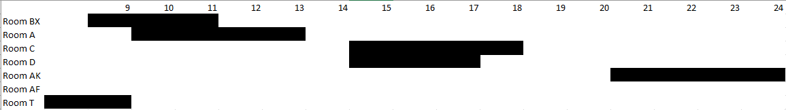



# Manage Access (Inventory)

System administrator must be able to modify permission levels for each employee accessing the main application.

You need to provide a solution for this task on your own.